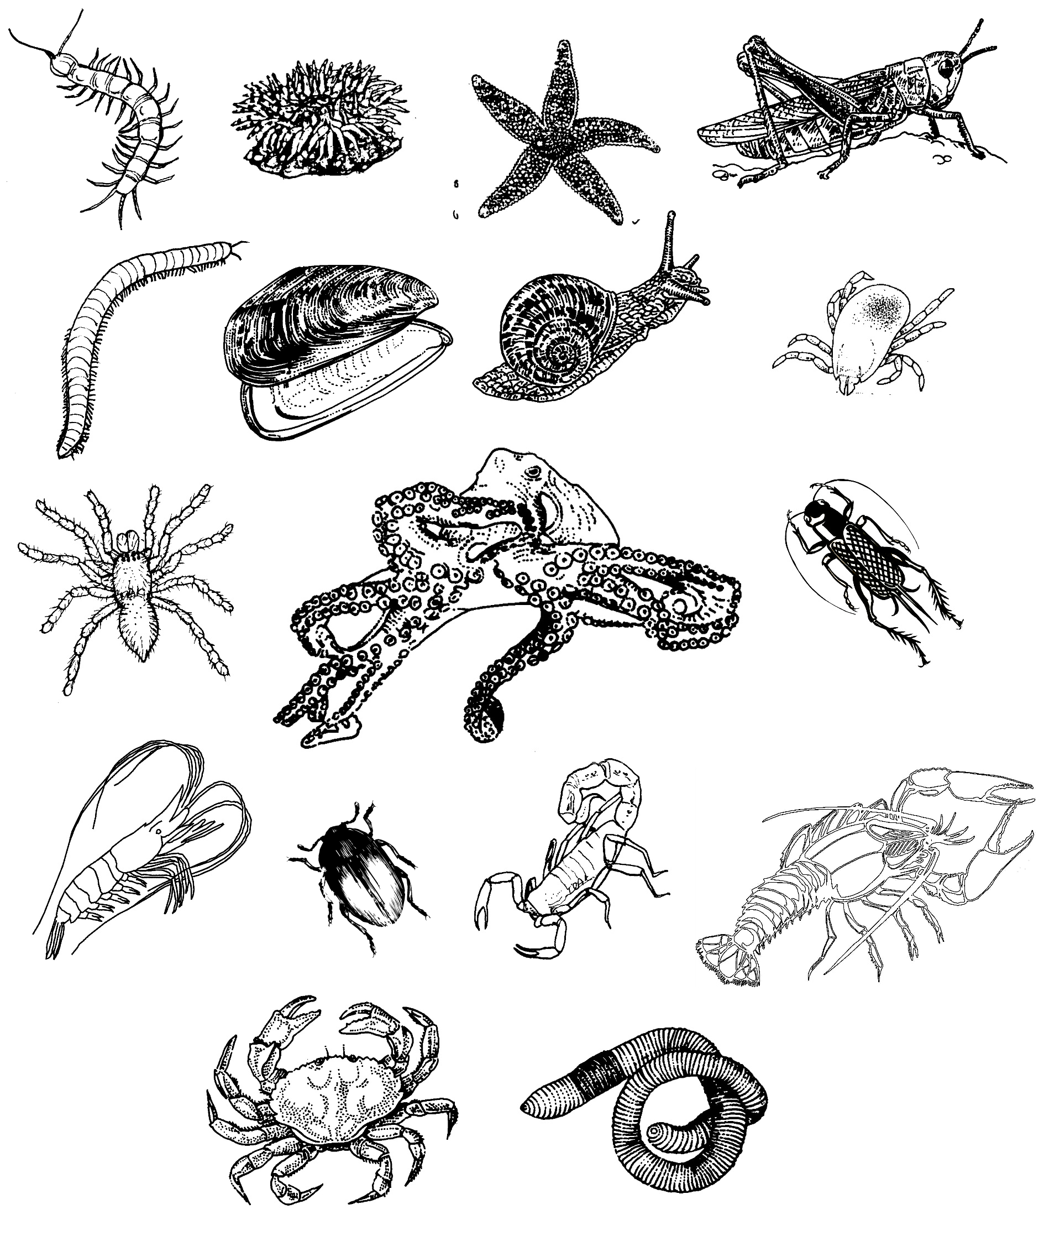
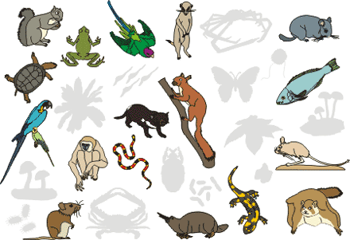
Course: Zoology
Instructor: Ms. Carrette
Text: Hickman, et alt. Integrated Principles of Zoology
McGraw Hill Publishing

Course Description: This course explores the diversity of life and the classification of life's organisms. Topics include taxonomy, evolution, ecology, body systems and behavior. Students will obtain a general knowledge of the anatomical and physiological components of vertebrates and compare them to invertebrates. Application of zoology in everyday life will also be stressed.

Course Content: The course will spend the first semester learning about the invertebrates that make up the Animal Kingdom and the second half of the semester will be spent learning about the chordates. Students will relate what they learn in class to real life issues involving the environment and animals. They will incorporate engineering concepts, by applying their knowledge in solving problems relating to the field of zoology. Students will at a minimum understand the following:
- Zoology is a discipline that interconnects with many other life sciences.
- There are patterns of organization that unify all members of the Kingdom Animalia.
- Kingdom Animalia comprises of invertebrates and vertebrates and includes animals that range in complexity (ex. Sponges →mammals).
- Scientists constantly work to classify animals.
- Invertebrates include: protists, poriferans, cnidarians, platyhelminthes, mollusks, annelids, arthropods, and echinoderms.
- Vertebrates include: fish, amphibians, reptiles, birds and mammals.
- Animals can be compared based on their anatomical and physiological characteristics.

See additional information about the course on the class website (www.mscarrette.weebly.com)

Grading: Students will be assessed on exams, quizzes (in class and online), HW/Class-work, labs, class participation and projects. At the end of each quarter students will complete an interim assessment that will be incorporated into their quarter grade. Grades will be available online at www.edline.net

Quarter Grade: Total Points Student Earned / Total Possible Points x 100 = Quarter Average

Students will be responsible for taking online quizzes. Some quizzes will be timed and you will only be able to take them once, but the majority of the quizzes you will be able to retake. If there is a retake option on the online quiz, you may keep retaking this quiz until you get 100%. (Ask Ms. Carrette how this works)

Online Quiz Website: http://quizstar.4teachers.org/

Class Participation: students will participate in class by periodically taking on the role as class secretary. As class secretary for the day, students will take attendance; collect handouts for students that are absent; and record in a class-log for the day.

Expectations: Students must attend class regularly, be on time to class, and bring all needed work materials to class. Students should always come to class appropriately attired and with a positive respectful attitude.

1. Food and drink are not allowed in class.
2. Profanity, putdowns, and obscene gestures are unacceptable and will not be tolerated
3. Walkmans, CD players, radios, phones, etc. are not allowed in class



Lab Safety: Parents/Guardian, Student and Teacher must all sign safety contract in order for the student to participate in lab. When in the lab, all students are required to adhere to the contract and conduct themselves in a safe manner. Improper acts will result in the student being asked to leave the lab and as a result receive a zero for that experiment. Second time violators will be prohibited from further lab use and therefore receive a zero on all subsequent labs.

Absences and Make-Up Work (As Directed in the NRHS Parent/Student Handbook)
“All work missed due to absence from school must be made up. Generally, students are allowed a day of make-up for a day of absence when not at school due to illness. It is the student’s responsibility to obtain the assignment on the day of his/her return to school. When assignments are given in advance or notice is given in advance for tests, students may be held responsible upon their return to school despite having been absent. Students who will be ill for an extended length of time (more than two missed days of school) may arrange to acquire assignments directly from their teachers. It is recommended that this be done by email contact: kcarrette@northreading.mec.edu.
If absence from class is due to tardiness, dismissal, guidance appointment etc., the student is responsible for obtaining the assignment that day and completing it for the day the assignment is due. No additional make-up time need be allowed. Students who will be absent from school due to family trips should make every effort to obtain available assignments in advance. All work (including tests) may be due the day that the student returns to school.
Students who receive an incomplete grade must submit all make-up work to the appropriate teacher no later than two (2) weeks after the closing of grades. Unless granted an extension by the teacher and/or the school administration, all incomplete grades will be changed to failures after this two (2) week period.”

Check your progress: Be responsible for your own work! Check your grades online at www.edline.net.

Extra Help: By appointment, I am available during powerblock and after school for extra help and make-up work. If a student wants one-on-one attention, after school appointments are recommended.

Academic Honesty: Academic honesty is expected of all students. Cheating in any form, including plagiarism, is a breach of this expectation. Plagiarism is defined as the taking and using of the thoughts, writings, inventions, etc., of another as one’s own. Plagiarism includes taking someone else’s work, writing, homework, or project, or copying someone’s quotations that come from an outside source, even a peer. This also applies to Internet use. Taking information from any website and claiming it as one’s own is a form of plagiarism as well. Students are reminded of the importance of using proper citation methods. Students who fail to adhere to the expectations of academic honesty, either through cheating or plagiarizing, are subject to receiving a lowered grade or a grade of zero on the assignment. Parents will be notified in cases of academic dishonesty. Additional consequences may be assigned depending upon the severity of the infraction.

Contact: Please contact Ms. Carrette via the contact form at: http://mscarrette.weebly.com/ or via email: kcarrette@north-reading.k12.ma.us


NRHS Core Values and Beliefs

At the core of North Reading High School is the common belief that effective citizenship and leadership in the twenty-first century begins with a commitment to life-long learning that is fostered in an environment that includes all students. We are a dynamic community of students, teachers, parents, and administrators with shared beliefs and values committed to developing capable, knowledgeable twenty-first century citizens. It is our mutual responsibility to be actively involved in a learning process that fosters higher-order thinking, problem solving, risk-taking, and innovation combined with academic rigor. We believe that an environment of collaboration, mutual respect, caring, and trust is the foundation for establishing a commitment to life-long learning. We believe that students learn best when they are connected to their community and can share in the obligations and duties of citizenship. North Reading High School embraces its opportunity to reach beyond its walls and is dedicated to preparing its students to be successful contributors to their local and global communities in the twenty-first century.

